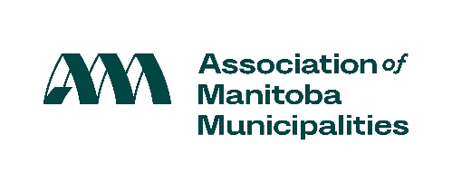

Proclaim the week of November 23-29, 2025 as Municipal Government Awareness Week!

Every effort is helpful to focus attention on the purpose and role of municipal government.

If your Council chooses this approach, here is a sample list of activities you might consider:

Sample Activities:

Proclamation – proclaim one week of the year as Municipal Government Awareness Week. Write up a media advisory and/or invite your local newspaper (see samples).

Community Event – e.g., community picnic, pancake breakfast, Family Day.

Open House/Tours – e.g., municipal office, fire hall, police station, water treatment plant.

Mayor/Reeve/Head of Council for a Day – run a contest for the position.

Job Shadowing – arrange for students to work in your municipal office to gain knowledge of local government.

Community Newsletter/Website – interview elected officials/staff, highlight/profile employees (what they do, why they like working for local government).

Activities for Schools – Members of Council to speak to local school/classroom, hold a mock Council meeting in classroom, encourage students to consider local government jobs.

Awards Event – provide awards to individuals contributing to your municipality.

Photo/Poster/Essay Contests – ask residents to make submissions highlighting their community.

Social Media – e.g., profile employees/places in your community, highlight community events.

Mayor/Reeve/Head of Council Note: If you would like to continue to designate another week of the year as Municipal Government Awareness Week, please feel free to do so. We encourage you to undertake a program that will best meet the needs of your municipality.

For more information, please visit:
http://www.amm.mb.ca/issues/municipal-government-awareness-week/

