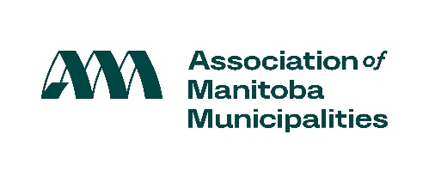

Proclaim the week of November 23-29, 2025 as Municipal Government Awareness Week!

Every effort is helpful to focus attention on the purpose and role of municipal government.

If your Council chooses this approach, here is a sample media advisory you might use:

Sample Media Advisory

Date: (insert date)

November 23-29, 2025 is Municipal Government Awareness Week. In honour of this week, (Mayor/Reeve/Head of Council) invites media to attend the following events hosted by (municipal government name).

Event Name and brief description
Date:
Location:

Event Name and brief description
Date:
Location:

(etc.)

For more information, please contact:

Name/Position:
Contact Information:

Mayor/Reeve/Head of Council Note: If you would like to continue to designate another week of the year as Municipal Government Awareness Week, please feel free to do so. We encourage you to undertake a program that will best meet the needs of your municipality.

For more information, please visit:
http://www.amm.mb.ca/issues/municipal-government-awareness-week/

