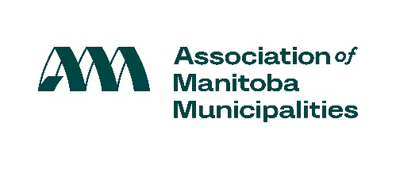

Proclaim the week of November 23-29, 2025 as Municipal Government Awareness Week!

Every effort is helpful to focus attention on the purpose and role of municipal government.

If your Council chooses this approach, here is a sample proclamation you might use:

Sample Proclamation:

Municipal Government Awareness Week 2025

WHEREAS community participation in municipal elections is important; and

WHEREAS community involvement in local government decision-making is essential to a healthy democratic system; and

WHEREAS community understanding of municipal government operations and the services it provides is of primary importance to meaningful participation at the local level;

NOW THEREFORE BE IT KNOWN THAT I, ______________(name)_________________, Mayor/Reeve/Head of Council of the __________(name of municipality)__________, do hereby proclaim the week of November 23-29, 2025 as MUNICIPAL GOVERNMENT AWARENESS WEEK.

___________________________________
Mayor/Reeve/Head of Council

Mayor/Reeve/Head of Council Note: If you would like to continue to designate another week of the year as Municipal Government Awareness Week, please feel free to do so. We encourage you to undertake a program that will best meet the needs of your municipality.

For more information, please visit:
http://www.amm.mb.ca/issues/municipal-government-awareness-week/

